Karthik Pradeep Hegadi

**2KE20CS032**

**Assignment 3 :File Management**

Additional comments (by course trainer):

step 5 : you should delete the testfolder1 along with the files, u shouldn't delete one by one step 11: you should have used different command, what if the file contains thousand lines, will u count it manually and subtract it?, u have to use dfifferent command for this

updated : please do refer for, ***step 5 : page no 3 , for step 11 : page no 8.***

**=================================================================**

**TASK 1**

1.Create few folders “testfolder1”,“testfolder2” in your home directory & list the folders that u have created

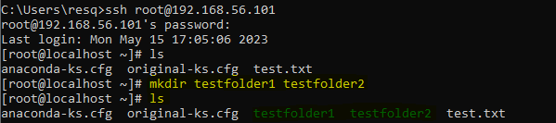

2.Create few files in testfolder1 named “file1.txt”,“file2.txt”,“file3.txt”

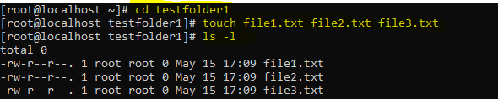

3.Copy “file1.txt” and “file2.txt” from testfolder1 to testfolder2

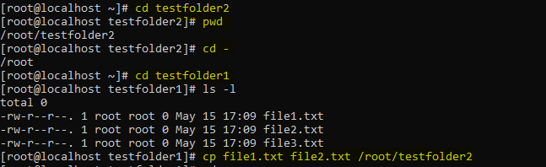

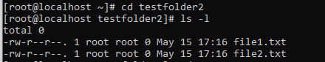

4.Create a softlink for “file3.txt” in testfolder2. 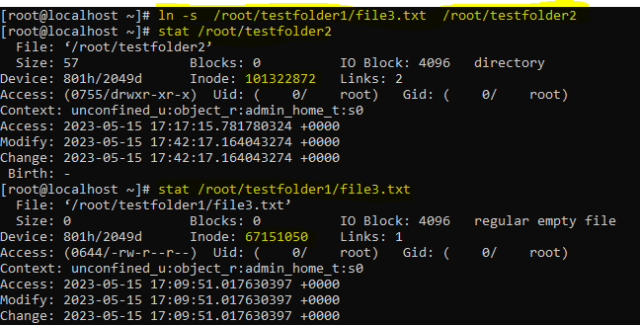

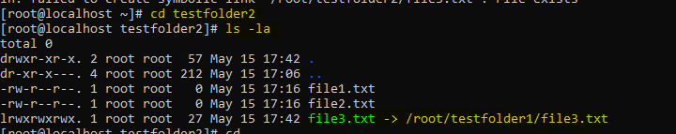

5.Delete “testfolder1” along with the files inside.

Type 1 : deleting one by one.

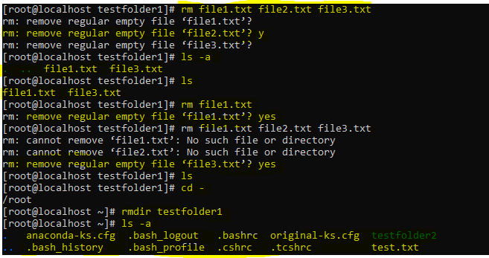

Type 2: Deleting the whole folder The following command will do it for you. Use caution though if this isn't your intention as this also removes files in the directory and subdirectories.

***rm -rf directoryname***

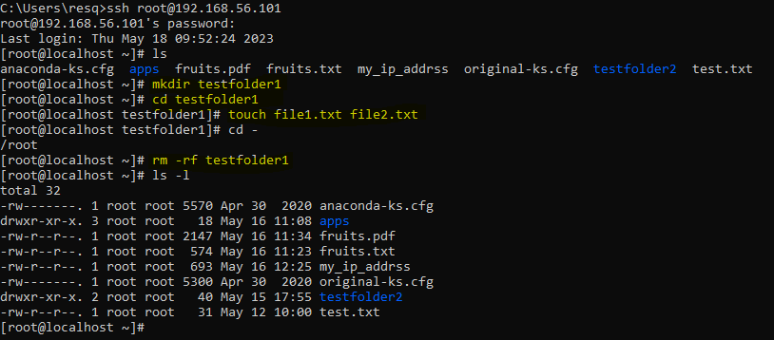

6.Find the dangling soft link and delete.

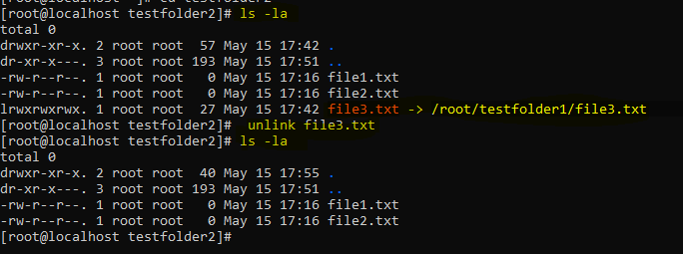

**TASK 2**

7.Create nested directories ”/root/apps/app1/bin” using single mkdir command.

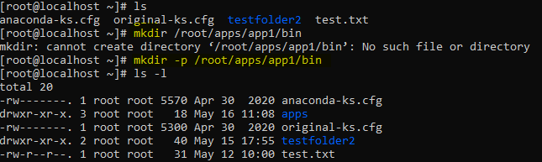

8.Create a file named fruits.txt inside ”/root/apps/app1/bin” and copy the contents attached in the pdf.

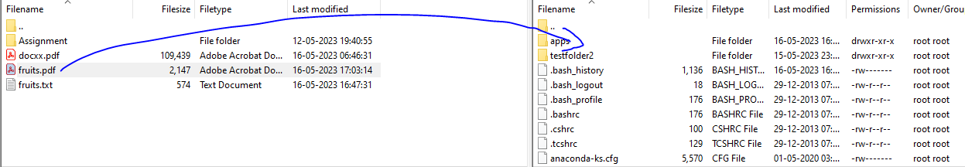

***Disclaimer: after transferring pdf its contents are not showing properly.***

***Thus, I asked permission of sir and converted in to txt document and transferred using file zilla application software.***

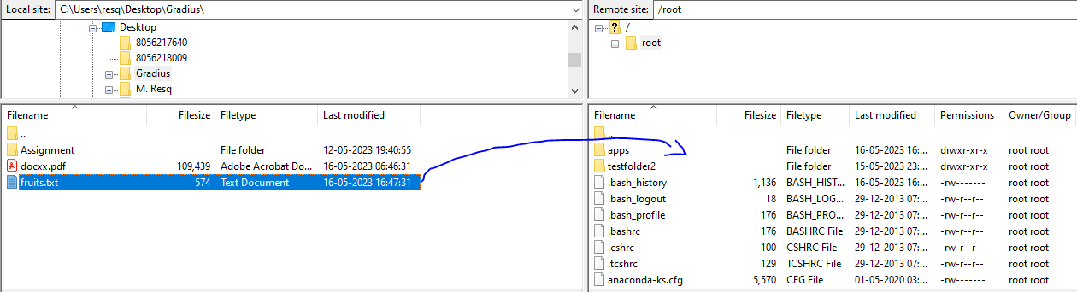**And copied**

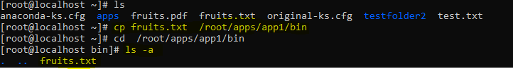

9.Display the contents in the “fruits.txt” using more command.

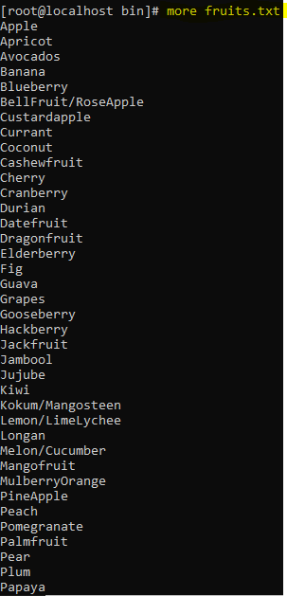

10.Display the contents in the“fruits.txt” using less command.



***Note: after using less command the content displayed and after we need to press “q” to quit.***

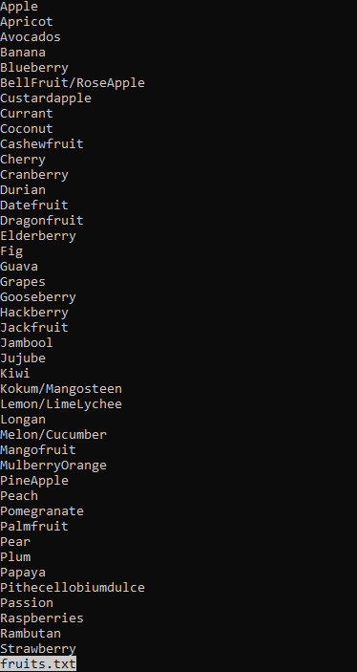

11.Display the last 5 lines in the“fruits.txt”.

Type 1 : counting the number of lines

***Note: to how the how many lines we can use scripting language but I have used “cat -n filename” where -n represents number of lines present in the fruits.txt file.***

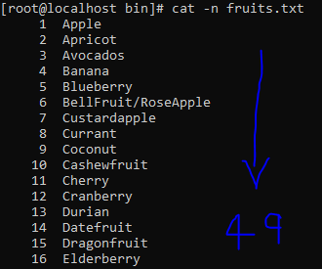

***Then I subtracted the total number of lies and printed the required line where (+45 indicates including 45th line to last line print it.)***

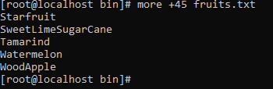

Type 2 : Using ***head tail*** command, here head refers to starting point of file and tail refers to end point of files and we do need to use the integer value to do so.

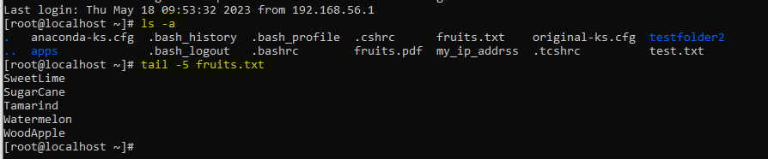

TASK 3

12.Create a hidden file using touch command(ex:touch.hidden.txt).

Creating the hidden file

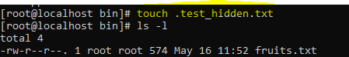

13.Display the hidden file using “ls-a”command



14.Display the current working Directory (you need to find out the command). 

15.Display your ip address using grep command.

***Thus to your ip address using grep command we can use scripting language but as far I use piplng concept that is I transfer one out put of command to another and search in that file using grep command which helps to find the patters in file.***

***Type 1***

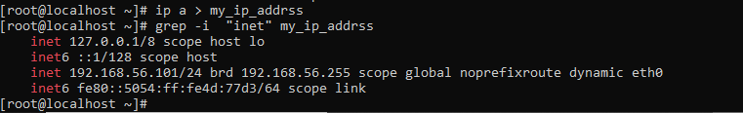

***Type 2***

